

Fundamentals of al and ml PROJECT REPORT

Course: CSE0001 || Date: 29th March 2026
Course: CSA2001 || Date: 30th March 2026

Name: Maharth Tiwari
Reg. No: 25BAI10291
Branch: CSE (AI & ML)
Year: First Year B.Tech

Abstract

This project report details the design, theoretical foundation, and implementation of a command-line Tic-Tac-Toe game developed in Python. The core objective of this project is to create an "unbeatable" artificial intelligence opponent. To achieve this, the game engine utilizes the Minimax algorithm—a fundamental concept in decision theory and game theory. Furthermore, the algorithm is optimized using Alpha-Beta pruning, significantly reducing the computational time required to evaluate the game tree. The report covers the system architecture, algorithmic logic, heuristic evaluation strategies, and provides a comprehensive code walkthrough of the resulting application.

Table of Content
- Introduction
- Theoretical Framework
  - 2.1 Game Theory in AI
  - 2.2 The Minimax Algorithm
  - 2.3 Alpha-Beta Pruning
- System Architecture and Design
  - 3.1 Board Representation
  - 3.2 Program Flow
- Implementation Details
  - 4.1 Initialization and Constants
  - 4.2 Win Detection Logic
  - 4.3 Minimax Implementation
  - 4.4 Artificial Intelligence Decision Making
- Testing and Sample Output
- Advantages and Limitations
- Future Scope
- Conclusion
- References

INTRODUCTION
Tic-Tac-Toe is a classic, zero-sum, two-player game played on a 3x3 grid. While the rules are simple, it serves as a perfect introductory model for exploring artificial intelligence in gaming. A standard human vs. human game often results in a draw if both players play optimally. The goal of this project is to program an AI (playing as 'O') that can never be defeated by a human player (playing as 'X'). It will either force a win or, at worst, secure a tie.
This project is implemented in Python, utilizing standard libraries, to demonstrate state-space search techniques, recursion, and algorithm optimization.

Theoretical Framework
2.1 Game Theory in AI
In artificial intelligence, games like Tic-Tac-Toe are classified as deterministic, two-player, zero-sum games with perfect information.
- Deterministic: There is no element of chance (like dice rolls).
- Zero-Sum: One player's gain is exactly the other player's loss.
- Perfect Information: Both players can see the entire state of the board at all times.
2.2 The Minimax Algorithm
The Minimax algorithm is a backtracking algorithm used in decision-making and game theory to find the optimal move for a player. It assumes that the opponent is also playing optimally. The algorithm generates a "game tree" of all possible future board states.
- Maximizer (The AI): Seeks to maximize the score (e.g., +10 for a win).
- Minimizer (The Human): Seeks to minimize the score (e.g., -10 for a human win).

2.3 Alpha-Beta Pruning
While Minimax is effective, traversing the entire game tree for complex games is computationally expensive. Alpha-Beta pruning is an optimization technique that stops evaluating a move when at least one possibility has been found that proves the move to be worse than a previously examined move.
- Alpha :The best (highest) value that the Maximizer can guarantee at that level or above.
- Beta : The best (lowest) value that the Minimizer can guarantee at that level or above.
If at any point beta <= alpha , the branch is "pruned" (ignored), saving processing power without altering the final optimal decision.

System Architecture and Design
The system is designed sequentially, primarily focusing on maintaining the game state and evaluating it recursively.
3.1 Board Representation
Instead of a 2D matrix, the game board is represented as a 1D Python list containing 9 elements. This approach simplifies indexing and iterating through the board.
- Indices: 0 through 8 represent the 9 squares from top-left to bottom-right.
- States: Each index can hold 'X' (Human), 'O' (AI), or ' ' (Empty).

3.2 Program Flow
- Initialization: The board array is initialized with empty strings.
- Display: The game prints a welcome message and an index guide map.
- Human Turn: * Prompts the user for a number between 0-8.
  - Validates the input (checks for out-of-bounds, non-integer inputs, and already occupied squares).
  - Updates the board.
- Terminal Check: The board is evaluated to see if 'X' won or if the board is full (Tie).
- AI Turn:
  - The get_best_move function initiates the Minimax search.
  - The recursive minimax function calculates the utility of all possible legal moves.
  - The AI places 'O' in the optimal square.
- Terminal Check: The board is evaluated for an 'O' win or a Tie.
- Loop: Steps 3-6 repeat until a terminal state is reached.

Implementation Detail
This section highlights the core Python components written for the project.
4.1 Constants and Win Detection Logic
Constants are defined globally to avoid hardcoding strings throughout the application, ensuring clean code.
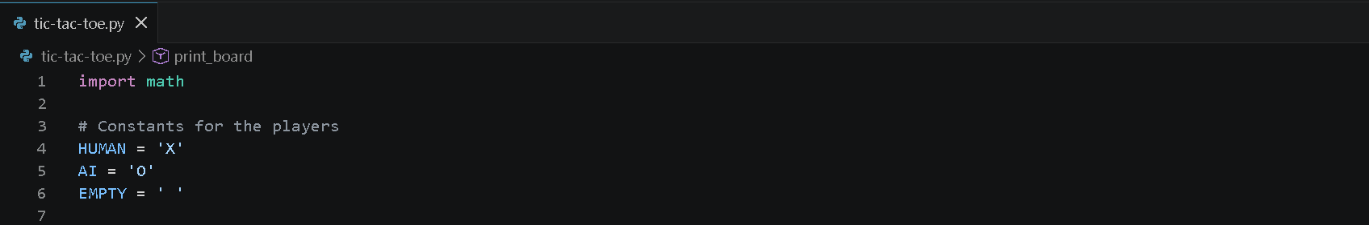
The check_winner(board) function evaluates 8 possible winning lines (3 rows, 3 columns, 2 diagonals). If a match is found, it returns the character of the winner. If no spaces remain, it returns 'TIE'.
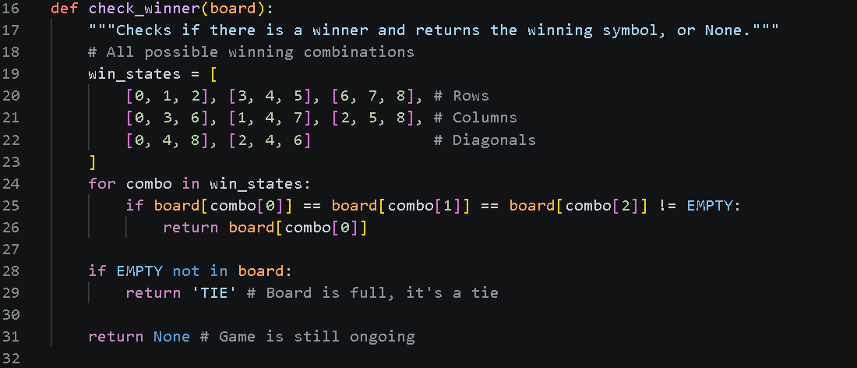
4.2 The Heuristic Evaluation (Depth Penalty)
A crucial part of the implementation is the scoring system inside the base case of the minimax function.
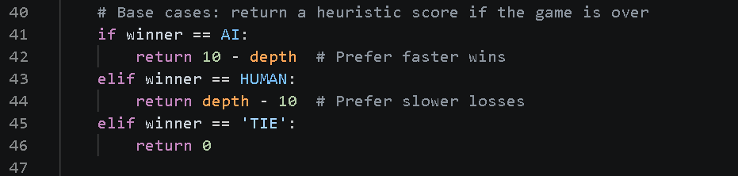
By subtracting the depth from the winning score, the AI is incentivized to choose the path that leads to a win in the fewest number of moves. Conversely, if a loss is inevitable, it will choose the path that delays the loss for as long as possible.
4.3 Minimax with Alpha-Beta Pruning Code Walkthrough
The recursive function is the brain of the application. It takes the current board, depth, a boolean indicating whose turn it is (is_maximizing), and the alpha and beta values.
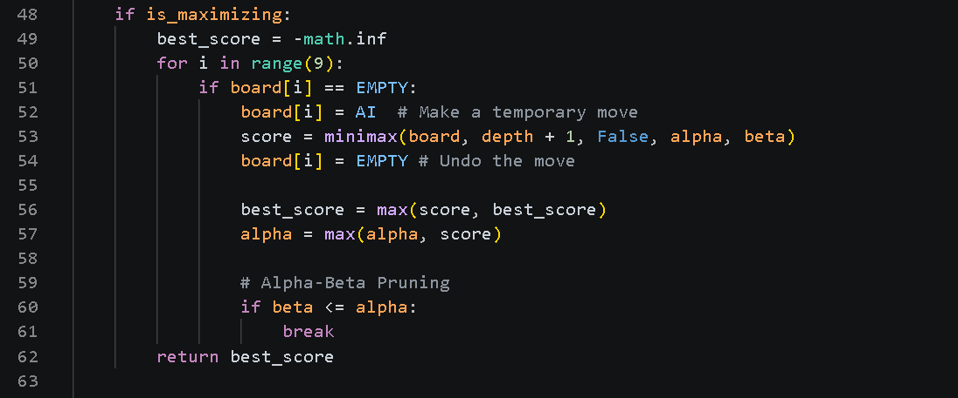
When it is the AI's turn (Maximizer), it iterates through available spots, simulates a move, and recursively calls minimax passing False (handing the turn to the Minimizer). If the simulated branch is worse than a previously found branch (beta <= alpha), the loop breaks, saving processing time.
4.4 Artificial Intelligence Decision Making
The get_best_move function acts as a wrapper for the minimax algorithm. It tracks the physical index (0-8) associated with the best score returned by the algorithm.
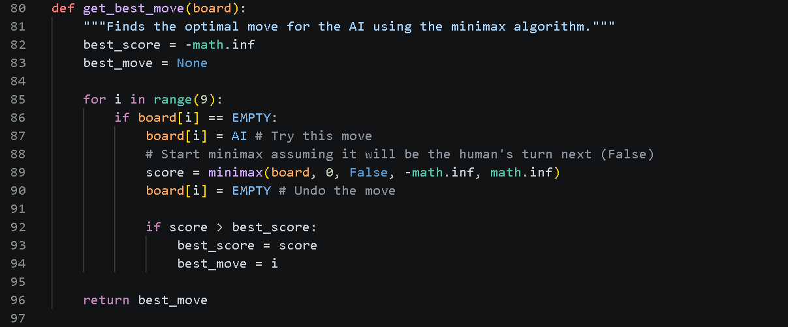

Testing and Sample Output
5. Testing and Sample Output
The system was extensively tested by playing against it using various strategies: attempting to win, attempting to trap the AI, and attempting to force a draw. Because the entire game tree is evaluated, the AI successfully blocks all traps and secures a tie when a win is mathematically impossible.
Sample Terminal Execution:
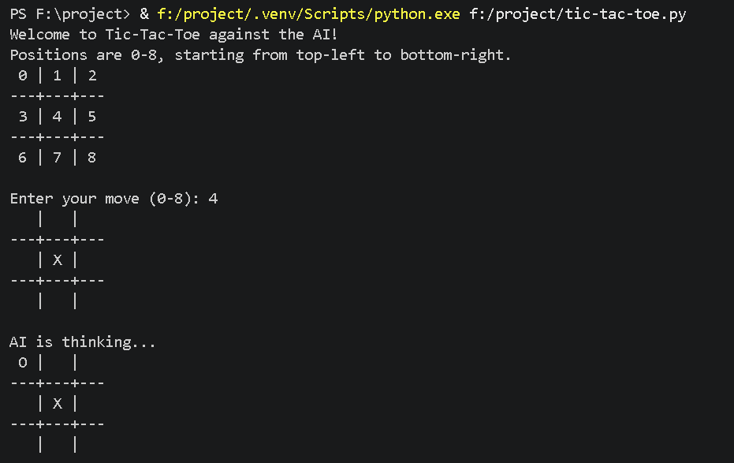
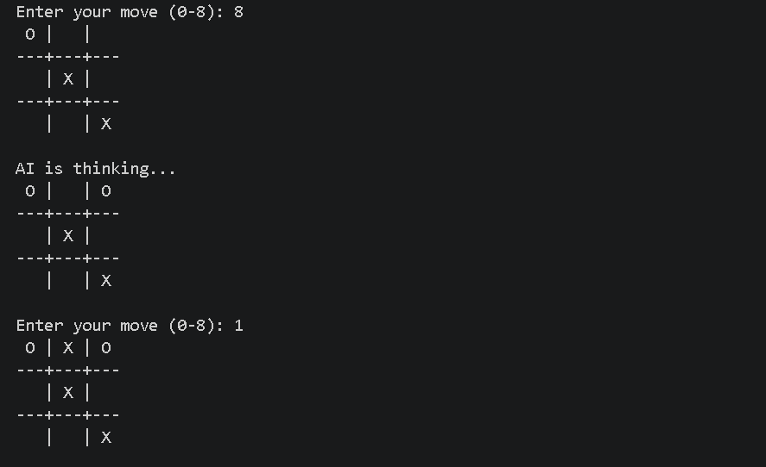
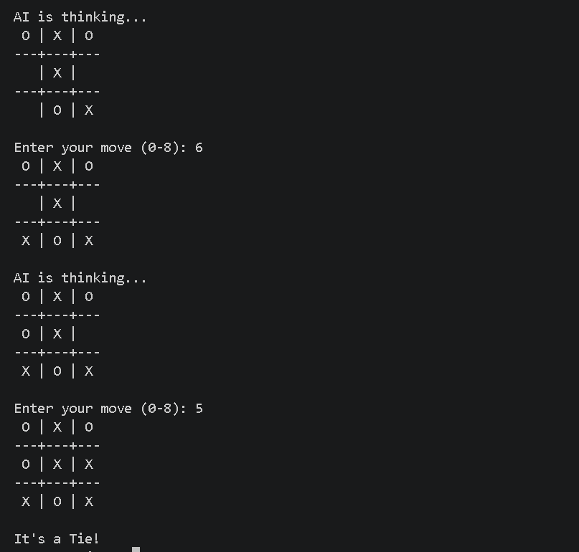

Conclusion and Future Scope
6. Advantages and Limitations
Advantages:
- Perfect Play: The implementation of Minimax ensures the AI will never lose a game.
- Efficiency: Alpha-Beta pruning drastically reduces the number of nodes evaluated. While a standard Tic-Tac-Toe game tree has 362,880 terminal nodes, pruning cuts the evaluation time to a fraction of a second.
- Error Handling: The try-except block gracefully handles non-integer inputs, preventing application crashes.
Limitations:
- Interface: The game is currently limited to a text-based Command Line Interface (CLI), which is not user-friendly for non-programmers.
- Scalability: While Minimax works perfectly for a 3x3 grid, scaling to an NxN grid (like Connect 4 or Gomoku) without adding depth limits and advanced heuristic boards would cause severe performance issues due to exponential time complexity.

7. Future Scope
The current implementation lays a strong foundation for several future enhancements:
- Graphical User Interface (GUI): Implementing a graphical interface using libraries such as Tkinter or Pygame to allow mouse-click interactions instead of keyboard integer inputs.
- Difficulty Levels: Introducing depth limitations to the Minimax algorithm. By artificially limiting how many turns ahead the AI can "see," we can create Easy, Medium, and Hard difficulties.
- Machine Learning: Replacing the search algorithm with a Reinforcement Learning agent (like Q-Learning), allowing the AI to "learn" how to play by playing millions of games against itself rather than relying on a hard-coded search tree.
8. Conclusion
This project successfully demonstrates the practical application of the Minimax algorithm and Alpha-Beta pruning. By carefully managing the game state array and applying recursion, an unbeatable Artificial Intelligence was created. The project, authored by Maharth Tiwari (Reg: 25BAI10291), highlights core concepts of computer science including decision theory, algorithm optimization, and state-space evaluation, fulfilling all proposed objectives.
9. References
- Russell, S. J., & Norvig, P. (2020). Artificial Intelligence: A Modern Approach (4th ed.). Pearson.
- Python Software Foundation. (n.d.). Python Language Reference, version 3.x. Available at http://www.python.org

